CHILDREN’S CHRISTMAS PARTY
Sunday 13th December
2.30 – 4.30pm
Afternoon Tea and Soft Drinks
Games and Entertainment
Special visit from Father Christmas
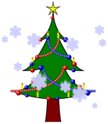 Bar open: 2pm 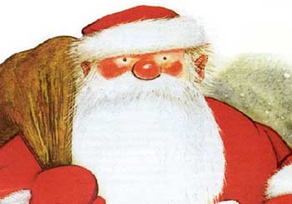
Tickets: £4 per child
(please bring a floor cushion, and parents to supply the Santa present)
To book your children and their friends a place, please email me on catering@warwickboatclub.co.uk, and let me know the names and ages of those joining in this festive, fun afternoon.
Ho ho ho!

Libby Newman
Social Committee

